AI Challenge for python developer

Requirements: Overview

An application that can compare and contrast two different insures policies based on natural language questions.

* Ask question regarding the policy.
* Choose at least two insures to compare.
* The model searches through document corresponding to selected insure.
* Get the results comparing the two.
* Or return non if no info found.

**Brief solution description:**

The solution will use strategy design pattern. The results will be based on the best strategy after the training and tuning of these strategies (ChatGPT, transformers and web scrapping).

In prod, the solution can be converted into any format required, i.e. web app, mobile etc.

**Use Case Diagram**

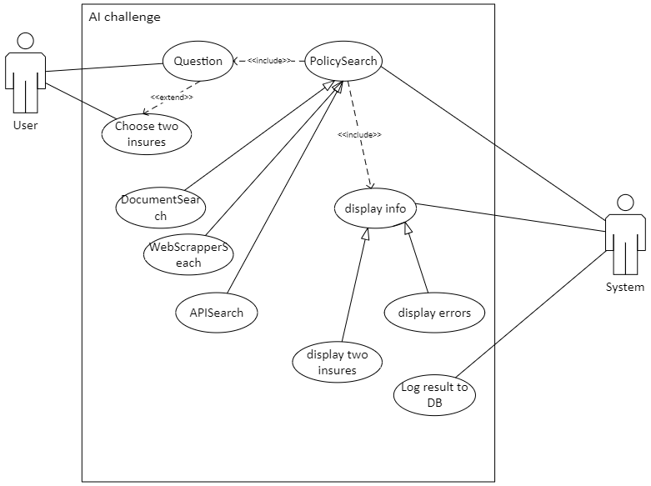

**Process Flow (still to be modified)**

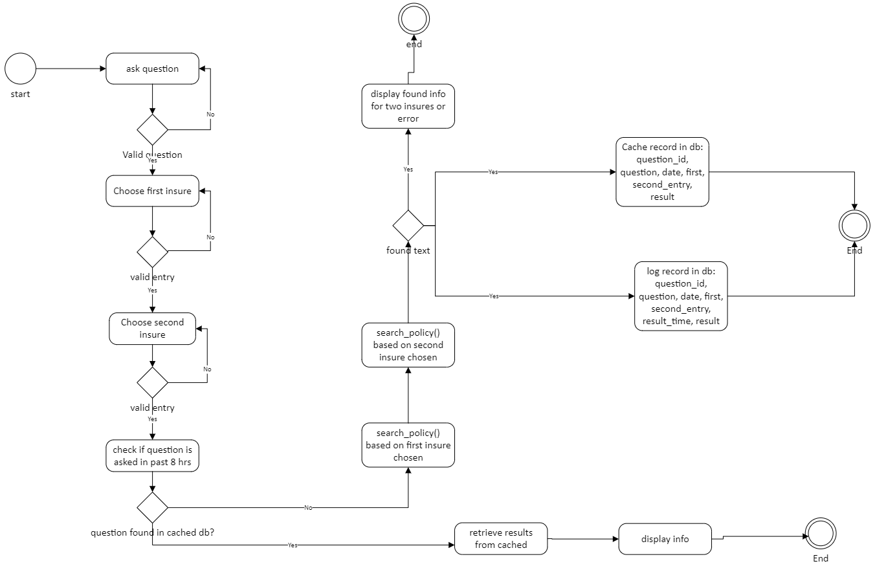

**Class Diagram (Still to be modified).**

